COMMAND LINE TOOL FOR WORKING WITH JSON WEB TOKENS (JWT)

A PROJECT REPORT

Submitted by

Khushi Garg (20BCY10043)
Vinayak Agrawal (20BCY10062)
Shaili Gupta (20BCY10134)

Anurag Sourav (20BCY10146)

in partial fulfillment for the award of the degree
of

BACHELOR OF TECHNOLOGY

in

COMPUTER SCIENCE AND ENGINEERING



SCHOOL OF COMPUTING SCIENCE AND ENGINEERING
VIT BHOPAL UNIVERSITY
KOTHRIKALAN, SEHORE
MADHYA PRADESH - 466114

MAY 2022

VIT BHOPAL UNIVERSITY, KOTHRIKALAN, SEHORE
MADHYA PRADESH – 466114

BONAFIDE CERTIFICATE

Certified that this project report titled “COMMAND LINE TOOL FOR WORKING WITH JSON WEB TOKENS (JWT)” is the Bonafede work of “KHUSHI GARG (20BCY10043), VINAYAK AGRAWAL (20BCY10062), SHAILI GUPTA (20BCY10134), ANURAG SOURAV(20BCY10146)” who carried out the project work under my supervision. Certified further that to the best of my knowledge the work reported at this time does not form part of any other project research work based on which a degree or award was conferred on an earlier occasion on this or any other candidate.

PROGRAM CHAIR PROJECT GUIDE
Dr. R. Rakesh, Assistant Professor Mr. Vikas Kumar Jain, Assistant Professor
School of Computer Science and Engineering School of Computer Science and Engineering
VIT BHOPAL UNIVERSITY VIT BHOPAL UNIVERSITY

The Project Exhibition II Examination is held on 27-05-2022

ACKNOWLEDGEMENT

First and foremost, we would like to thank the Lord Almighty for His presence and immense blessings throughout the project work.
We wish to express our heartfelt gratitude to Dr. R. Rakesh, Head of the Department, School of Computer Science and Engineering for much of his valuable support encouragement in carrying out in carrying out this work.
We would like to thank our internal guide Mr. Vikas Kumar Jain, for continually guiding and actively participating in our project, giving valuable suggestions to complete the project work.
We would like to thank all the technical and teaching staff of the School of Computer Science and Engineering, who extended directly or indirectly all support.
Last, but not least, we are deeply indebted to our parents who have been the greatest support while we worked day and night for the project to make it a success.

LIST OF ABBREVIATIONS

Cipher – Ciph.
Privacy – prvy.
Security – secy.
encryption - encrt.
decryption - decrt.
project - prt.

LIST OF FIGURES AND GRAPHS

FIGURE NO.  - Functional Module Design and Analysis 20  - Software Architectural Design 20  - The Final look of the Website for the Project 21  - Modified Vigenere Table 23  - Encryption process 28  - Encryption process 29  - Decryption process 29  - Letter count line Graph 37  - Caesar cipher performance frequency graph 39 | TITLE | PAGE NO.

ABSTRACT

JSON Web Token (JWT) is a means of representing claims to be transferred between two parties. The claims in a JWT are encoded as a JSON object that is digitally signed using JSON Web Signature (JWS) and/or encrypted using JSON Web Encryption (JWE).
JWTs are an encoded representation of a JSON object. It is widely used these days for authorization purposes. It is used to send information between parties in a compact and secure manner. It can have different usages: authentication mechanism, url-safe encoding, securely sharing private data, interoperability, data expiration, etc. JWTs can be used by a server to tell the client app what actions the user is allowed to execute.
We have created a terminal-based tool using Java Script and its libraries for generating JWT Token using the method of encryption and decryption. Many tools exist which uses cookie-based authentication we will be using it using JWT.
JWT is a great alternative to cookie-based authentication approach. It can have different usages: authentication mechanism, URL-safe encoding, securely sharing private data, interoperability, data expiration, etc. JWTs can be used by a server to tell the client app what actions the user is allowed to execute.

TABLE OF CONTENTS

CHAPTER NO. | TITLE | PAGE NO.
 | List of Abbreviations  List of Figures and Graphs  Abstract | 4  5  6
1 | CHAPTER-1:  PRTOJECT DESCRIPTION AND OUTLINE  Introduction  Motivation for the work  - Jwt-based authentication  1.5 Problem Statement  1.6 Objective of the work  1.7 Organization of the project  1.8 Summary | 10
2 | CHAPTER-2:  RELATED WORK INVESTIGATION  2.1 Introduction  2.2 Core area of the project  2.3 Existing Approaches/Methods  2.3.1 Approaches/Methods -1  2.3.2 Approaches/Methods -2  2.4 Pros and cons of the stated Approaches/Methods  2.5 Issues/observations from investigation  2.6 Summary | 13
3 | CHAPTER-3:  REQUIREMENT ARTIFACTS  3.1 Introduction  3.2 Hardware and Software requirements  3.3 Specific Project requirements  3.3.1 Data requirement  3.3.2 Functions requirement  3.3.3 Performance and secy. requirement  3.4 Summary | 17
4 | CHAPTER-4:  DESIGN METHODOLOGY AND ITS NOVELTY  4.1 Methodology and goal  4.2 Functional modules design and analysis  4.3 Software Architectural designs/ snapshot of project  4.4 Summary | 19
5 | CHAPTER-5:  TECHNICAL IMPLEMENTATION & ANALYSIS  5.1 Outline  5.2 Technical coding and code solutions  5.3 Prototype submission  5.4 Test and validation  5.5 Performance Analysis (Graphs/Charts)  5.6 Summary | 21
6 | CHAPTER-6:  PRTJECT OUTCOME AND APPLICABILITY  6.1 Outline  6.2 key implementations outlines of the System  6.3 Significant project outcomes  6.4 Project applicability on Real-world applications  6.4 Inference | 27
7 | CHAPTER-7:  CONCLUSIONS AND RECOMMENDATION  7.1 Outline  7.2 Limitation/Constraints of the System  7.3 Future Enhancements  7.4 Inference | 29
 | References | 44

CHAPTER 1 PROJECT DESCRIPTION AND OUTLINE

1.1 INTRODUCTION

JSON Web Token (JWT) is a compact token format intended for space constrained environments such as HTTP Authorization headers and URI query parameters. JWTs encode claims to be transmitted as a JSON object (as defined in RFC 4627 [RFC4627]) that is base64url encoded and digitally signed and/or encrypted. Signing is accomplished using JSON Web Signature (JWS) [JWS]. Encryption is accomplished using JSON Web Encryption (JWE) [JWE]. The suggested pronunciation of JWT is the same as the English word "jot".

JSON WEB TOKEN (JWT) OVERVIEW

JWTs represent a set of claims as a JSON object that is base64url encoded and digitally signed and/or encrypted. The JWT Claims Set represents this JSON object. As per RFC 4627 [RFC4627] Section 2.2, the JSON object consists of zero or more name/value pairs (or members), where the names are strings and the values are arbitrary JSON values. These members are the claims represented by the JWT.
The member names within the JWT Claims Set are referred to as Claim Names. The corresponding values are referred to as Claim Values.
The bytes of the UTF-8 representation of the JWT Claims Set are signed in the manner described in JSON Web Signature (JWS) [JWS] and/or encrypted in the manner described in JSON Web Encryption (JWE) [JWE].
The contents of the JWT Header describe the cryptographic operations applied to the JWT Claims Set. If the JWT Header is a JWS Header, the claims are signed. If the JWT Header is a JWE Header, the claims are encrypted.
A JWT is represented as the concatenation of the Encoded JWT Header, the JWT Second Part, and the JWT Third Part, in that order, with the parts being separated by period ('.') characters. When signed, the three parts of the JWT are the three parts of a JWS used to represent the JWT. When encrypted, the three parts of the JWT are the three parts of a JWE used to represent the JWT.

  - MOTIVATION FOR THE WORK
We found many prototypes similar for the cause but not each one of them compelled to provide any output in ease and maximum secy. in terms of prvy. / data breach. Numerous crime stories are burdened over internet which gave a common link i.e., Secy. Breach of any confidential data made a huge loss either to an organization or an individual. We realized the major problem why a common man is unable to access the secy. medium and fears losing whatever hard-earned. This made us prepare the prototype.
  - JWT-BASED AUTHENTICATION
WT-based authentication
In a typical JWT-based access control scheme, the ini-
tial user authentication is done using a traditional
method, for example, providing a username and pass-
word combination.
Upon successful authentication, the authorization
details of the user, such as identifiers, roles, and permis-
sions, are packed into a JWT. The token is then
encrypted using a shared encryption key (called the JWT
secret) ensuring verifiability at each secured endpoint.
This token is passed along each subsequent request
by the client (known as a ‘‘bearer token’’), decrypted
and unpacked by the service, and the access control
data from the token is retrieved. In the security termi-
nology, we usually call these tokens as access tokens.
Accessing a secured resource through this scheme
entails the following procedure:
1. The client sends an authentication request using
a pre-defined method, such as a username–
password combination.
2. The authentication service, after checking the cre-
dentials of the user, creates a JWT from the
retrieved user authorization data. This token is
encrypted using the JWT secret and then returned
to the client, but not stored in the server.
3. The client passes along this token with the
request to a secured resource.
4. The secured service receives the request,
decrypts the attached token, and unpacks the
user authentication data from it. Using this
information, the request can be authorized or
denied, and a proper response is sent.
For added user comfort, most solutions integrate
another layer of authentication by providing refresh
tokens (similar to the concept known from the OAuth
protocol).
2
These long-lived tokens are assigned upon
successful authentication and can be used to request
new access tokens. This can be done invisibly to the
user, unlike a request for username and password
WT-based authentication
In a typical JWT-based access control scheme, the ini-
tial user authentication is done using a traditional
method, for example, providing a username and pass-
word combination.
Upon successful authentication, the authorization
details of the user, such as identifiers, roles, and permis-
sions, are packed into a JWT. The token is then
encrypted using a shared encryption key (called the JWT
secret) ensuring verifiability at each secured endpoint.
This token is passed along each subsequent request
by the client (known as a ‘‘bearer token’’), decrypted
and unpacked by the service, and the access control
data from the token is retrieved. In the security termi-
nology, we usually call these tokens as access tokens.
Accessing a secured resource through this scheme
entails the following procedure:
1. The client sends an authentication request using
a pre-defined method, such as a username–
password combination.
2. The authentication service, after checking the cre-
dentials of the user, creates a JWT from the
retrieved user authorization data. This token is
encrypted using the JWT secret and then returned
to the client, but not stored in the server.
3. The client passes along this token with the
request to a secured resource.
4. The secured service receives the request,
decrypts the attached token, and unpacks the
user authentication data from it. Using this
information, the request can be authorized or
denied, and a proper response is sent.
For added user comfort, most solutions integrate
another layer of authentication by providing refresh
tokens (similar to the concept known from the OAuth
protocol).
2
These long-lived tokens are assigned upon
successful authentication and can be used to request
new access tokens. This can be done invisibly to the
user, unlike a request for username and password
JWT-based authentication In a typical JWT-based access control scheme, the initial user authentication is done using a traditional method, for example, providing a username and pass-word combination.
Upon successful authentication, the authorization details of the user, such as identifiers, roles, and permissions, are packed into a JWT. The token is the encrypted using a shared encryption key (called the JWT secret) ensuring verifiability at each secured endpoint.
This token is passed along each subsequent request by the client (known as a ‘‘bearer token’’), decrypted and unpacked by the service, and the access control data from the token is retrieved. In the security terminology, we usually call these tokens as access tokens. Accessing a secured resource through this scheme details the following procedure:
1. The client sends an authentication request using a pre-defined method, such as a username–password combination.
2. The authentication service, after checking the credentials of the user, creates a JWT from the retrieved user authorization data. This token is encrypted using the JWT secret and then returned to the client, but not stored in the server.
3. The client passes along this token with the request to a secured resource.
4. The secured service receives the request, decrypts the attached token, and unpacks the user authentication data from it. Using this information, the request can be authorized or denied, and a proper response is sent.
For added user comfort, most solutions integrate another layer of authentication by providing refresh tokens (similar to the concept known from the OAuth protocol). These long-lived tokens are assigned upon successful authentication and can be used to request new access tokens. This can be done invisibly to the user, unlike a request for username and password.

  - PROBLEM STATEMENT
Session IDs are vulnerable to session fixation attacks. Session value does not timeout or does not get invalidated after logout Passwords, session IDs, and other credentials are sent over unencrypted connections. Proper session authentication is required which can be done by JWT tokens
  - OBJECTIVE OF THE WORK
To create a terminal-based tool using Java Script and its libraries for generating JWT Token using the method of encryption and decryption.
Many tools exist which uses cookie-based authentication we will be using it using JWT.

  - ORGANIZATION OF THE PRT.

The prt. was completed by four students of Cyber Dept. under School of Computer Science and Engineering { Khushi Garg (20BCY10043), Vinayak Agrawal (20BCY10062), Shaili Gupta (20BCY10134), Anurag Sourav (20BCY10146) } under the guidance of our internal guide, Mr. Vikas Kumar Jain, Assistant Professor and with valuable support of Dr. R. Rakesh, Head of the Department, School of Computer Science and Engineering.

  - SUMMARY

JSON Web Token (JWT) is an open standard (RFC 7519) that defines a compact and self-contained way for securely transmitting information between parties as a JSON object. This information can be verified and trusted because it is digitally signed. JWTs can be signed using a secret (with the HMAC algorithm) or a public/private key pair using RSA or ECDSA. Although JWTs can be encrypted to also provide secrecy between parties, we will focus on signed tokens. Signed tokens can verify the integrity of the claims contained within it, while encrypted tokens hide those claims from other parties. When tokens are signed using public/private key pairs, the signature also certifies that only the party holding the private key is the one that signed it.
CHAPTER 2 RELATED WORK INVESTIGATION

2.1 INTRODUCTION
JSON Web Token (JWT) is an open standard (RFC 7519) that defines a compact and self-contained way for securely transmitting information between parties as a JSON object. This information can be verified and trusted because it is digitally signed. JWTs can be signed using a secret (with the HMAC algorithm) or a public/private key pair using RSA or ECDSA.
Although JWTs can be encrypted to also provide secrecy between parties, we will focus on signed tokens. Signed tokens can verify the integrity of the claims contained within it, while encrypted tokens hide those claims from other parties. When tokens are signed using public/private key pairs, the signature also certifies that only the party holding the private key is the one that signed it
2.2 CORE AREA OF PRT.
The prt. was proposed at first with the basic idea of encrt. and decrt. techniques using ciph.s. Further the research work gave us the core idea where the prt. was initiated with the prior concept and initial framework was prepared. Fixing all errors and debugging the issues in code the 1st step, i.e., the base structure of the prt. was prepared. Following up with the Internal Guide, the research paper analysis was initiated with immediate effect and arrived on 4 problem statements, where one of the PR was finalized and final execution of code and frontend interface was executed.
2.3 EXISTING APPROACHES/METHODS
2.3.1 Approaches/Methods -1
Choose the Most Appropriate Algorithm
A JSON Web Token consists of 3 parts as Header, Payload, and Signature. The header contains information about the token type and the signing algorithm.
{"alg": "HS256", "typ": "JWT" }
There are many types of signing algorithms available, and each of them has unique features. For example, symmetric algorithms likeHMAC + SHA256(HS256) algorithm allows you to sign messages using a shared secret key, while the asymmetric algorithms RSASSA-PKCS1-v1_5 + SHA256(RS256) and ECDSA + P-256 + SHA256(ES256) uses a public and private key pair.

2.3.2 Approaches/Methods -2
Always Sign the Token
After selecting an appropriate algorithm, you must always sign the token before sending it. JWT signature is the fundamental security feature that ensures data (payload) within the token has not been altered. To create a JWT signature, you need the encoded header, the encoded payload, a secret, and the algorithm specified in the header. For example, signature with HMACSHA256 algorithm would look like this:
HMACSHA256(
base64UrlEncode(header) + “.” +
base64UrlEncode(payload),
secret)
So, if there are any changes in the header or payload, you will have to create a new token signature. Also, you can include a random token ID in the jti claim to prevent two tokens from having the very same signature at the same time.
2.4 Pros and cons of the stated Approaches/Methods
Pros
No Database Table: This implies fewer DB queries, which implies faster response time. In case you are using paid services like DynamoDb that charge per query basis, JWT might reduce the costs marginally. But these can be resolved using tools like Redis in case of sessions
Simpler to use if careful : If your architecture doesn’t user client Sessions and your security basics are clear, the development time in case of JWT is faster using the existing libraries.
Used across services : You can have one authorization server that deals with the Login/Registration and generates the token, all the subsequent requests will need not have to go to the authorization server as the only the Auth-server will have have the private key, and rest of the severs will have the public-key to verify the signature.
This is really useful in case of corporate systems where in the authorization server is in a secure environment. e.g. a user needs to be connected to the intranet to login but once done, the public servers can verify and proceed on.
Similar setup can be used for OAuth implementation.
The best part is that there is no connection between the the auth-server and the rest of the servers other than the pre-defined public key.
Cons
Compromised Secret Key: The best and the worst thing about JWT is that it relies on just one Key. Consider that the Key is leaked by a careless or a rogue developer/administrator, the whole system is compromised! The attacker(who has access to the Key) can easily access all user data if he has the user-id which can be easily acquired. The only way to recover from this point is to generate a new Key(Key-pair) that will be used across systems here on. This would me all the existing client tokens are invalidated and each user would have to login again. Image one day 100% of Facebook users will be logged out. Well you might wonder, why is the same not possible if the developer/administrator leaks the Session table?
It is possible, but it is related to the practicality of the situation. Remember, most of the online breaches are done with social engineering than complicated technical hacks.
a) Practically it is really difficult to leak the whole table. In case of a single key, the admin just has pretend to take a photo of his friend in the office and the secret is on Reddit the next morning you fire him.
b) As well consider the OpenSSL Heartbleed bug. It is really easy to extract the secret key from just a couple of memory dumps with a simple string match script.

2.6 SUMMARY
JWT is a simple yet reliable mechanism to share security information between two parties. But, when you are using JWT, you need to be aware of the best practices to get the maximum from it.We had several cases where we wanted the users at HelpTap to logout by cleaning up the cookies, but we cannot ask them to do so every time. As well consider the case that a user’s mobile is stolen, and he wants to logout of all existing sessions(e.g. Gmail’s logout other sessions feature). Well its not possible in case of JWT. In our case it used to be rogue users. We needed to log them out. Well, in case of of HelpTap it was quite easy as we just had to delete the session tokens. There was no way to do the same in case of Bottr cause we used JWT in that case. You might argue, why not just delete the existing user-id from the table… But doing so means to create multiple dangling pointers and no one likes dangling pointers in a No-SQL database.

CHAPTER-3 REQUIREMENT ARTIFACTS
3.1 Introduction
As JSON is less verbose than XML, when it is encoded its size is also smaller; making JWT more compact than SAML. This makes JWT a good choice to be passed in HTML and HTTP environments. Security-wise, SWT can only be symmetric signed by a shared secret using the HMAC algorithm. While JWT and SAML tokens can also use a public/private key pair in the form of a X.509 certificate to sign them. However, signing XML with XML Digital Signature without introducing obscure security holes is very difficult compared to the simplicity of signing JSON. JSON parsers are common in most programming languages, because they map directly to objects, conversely XML doesn’t have a natural document-to-object mapping. This makes it easier to work with JWT than SAML assertions. Regarding usage, JWT is used at an Internet scale. This highlights the ease of client-side processing of JWTs on multiple platforms, especially, mobile.
3.2 Hardware and Software requirements
Hardware Requirements
1-2mb disk space
64bit processor
laptop/desktop
Software Requirements
PyCharm
VM Ware (Linux)
Node Js
Vs Code
Git
PYTHON This language is used for framing the code of the encrt. tool.
JAVA SCRIPT It is used for creating the Front-End Interface for ease in using the tool.
HTML The core-frame of Prt. is where the tool will be embedded.
VS CODE Visual Studio Code is an integrated development environment where the prt. is being made.
3.3 Specific Prt. requirements
3.3.1 Data requirement
- All data regarding Caesar ciph. was collected.
- All information about existing techniques were obtained.
3.3.2 Functions requirement
- The functions of python code were collected.
- The functions of JavaScript for preparing Front-end interface were also collected.
3.3.3 Performance and secy. requirement
- A smooth platform to initiate the code was found, i.e., VS Code
- The repository for the prt. was made Private and only accessible to members of team.

3.4 SUMMARY
JWT is a great alternative to cookie-based authentication approach. It can have different usages: authentication mechanism, url-safe encoding, securely sharing private data, interoperability, data expiration, etc .JWTs can be used by a server to tell the client app what actions the user is allowed to execute

CHAPTER 4 DESIGN METHODOLOGY AND ITS NOVELTY
4.1 METHODOLOGY AND GOAL

We are going to create a terminal-based tool using Java Script and its libraries for generating JWT Token using the method of encryption and decryption. Many tools exist which uses cookie-based authentication we will be using it using JWT.

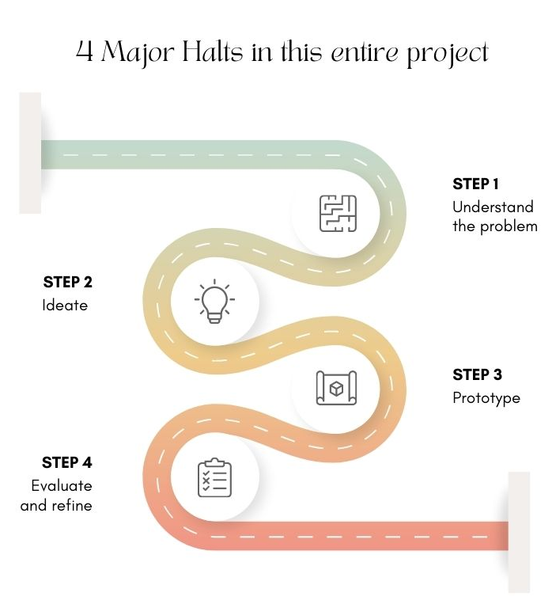
4.2 FUNCTIONAL MODULES DESIGN AND ANALYSIS
- Run the tool.
- In the login field the user submit the credentials.
- The server generates the verification token and return it to browser.
- Browser will send token with request to a restricted source.
- Server will identify the token whether the public & private key signatures are correct and the will respond to client

Figure 1

4.3 SOFTWARE ARCHITECTURAL DESIGNS / SNAP SHOT OF PROJECT

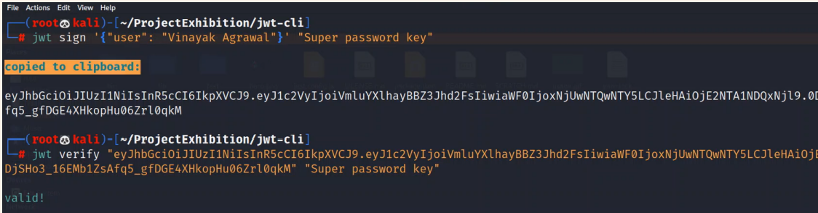

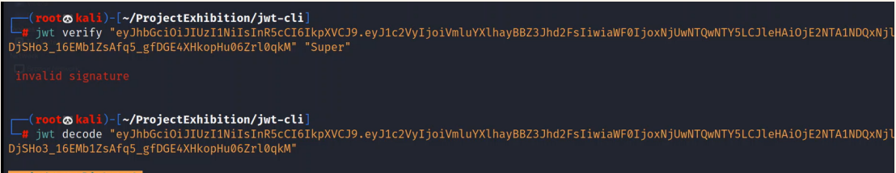

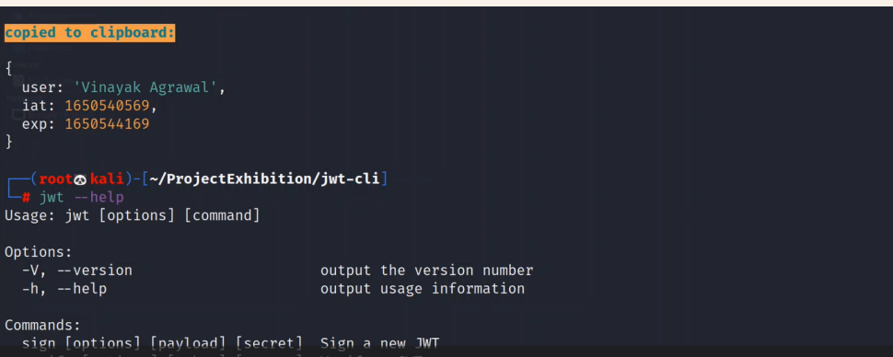

4.5 Summary

We are going to create a terminal-based tool using Java Script and its libraries for generating JWT Token using the method of encryption and decryption. Many tools exist which uses cookie-based authentication we will be using it using JWT.
The tool gives a command line interface to a cyber security enthusiast or anyone related to the field. It provides a way for securely transmitting information between different parities in the form of JSON object. The sent or received information can be verified because they are digitally signed.

CHAPTER 5 TECHNICAL IMPLEMENTATION & ANALYSIS

5.1 OUTLINE
The analysis of research papers gave certain problem statements.
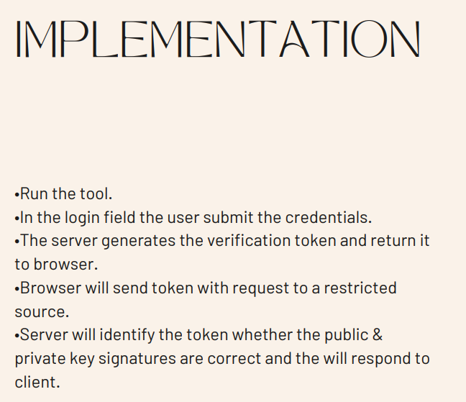

PROBLEM STATEMENT:
- Session IDs are vulnerable to session fixation attacks.
- Session value does not timeout or does not get invalidated after logout
- Passwords, session IDs, and other credentials are sent over unencrypted connections.
- Proper session authentication is required which can be done by JWT tokens
JWT Structure
Token itself consists of three parts: header, payload and signature.
- header contains encoded type of the token and algorithm
- payload contains encoded data and additional metadata
- signature is encoded header + encoded data + secret phrase, encoded with algorithm

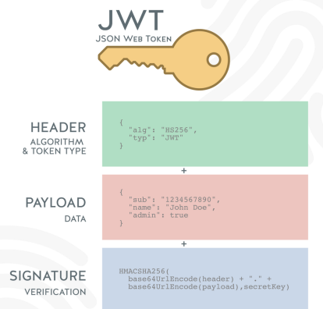
5.2 TECHNICAL CODING AND CODE SOLUTION

Snapshot of Code
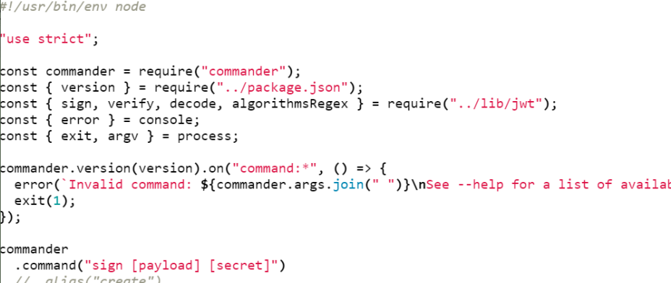

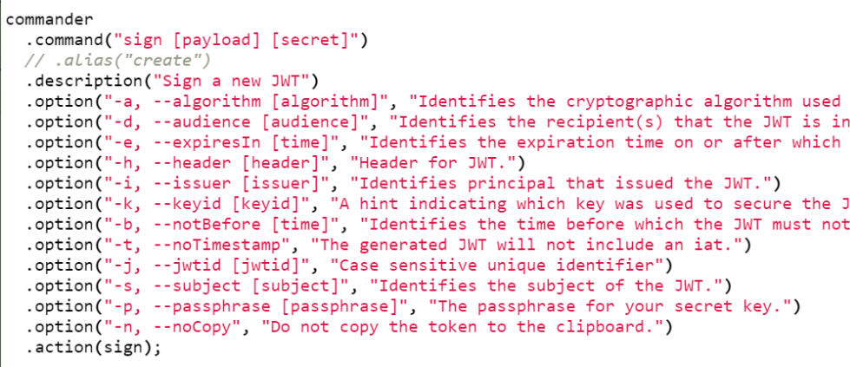

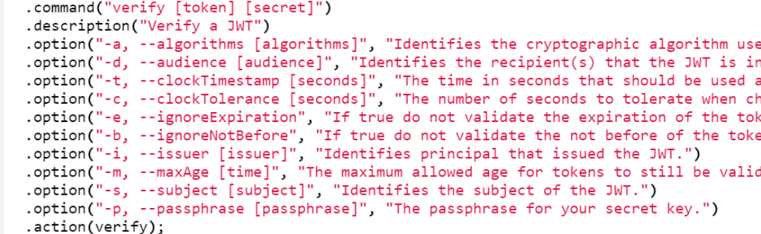

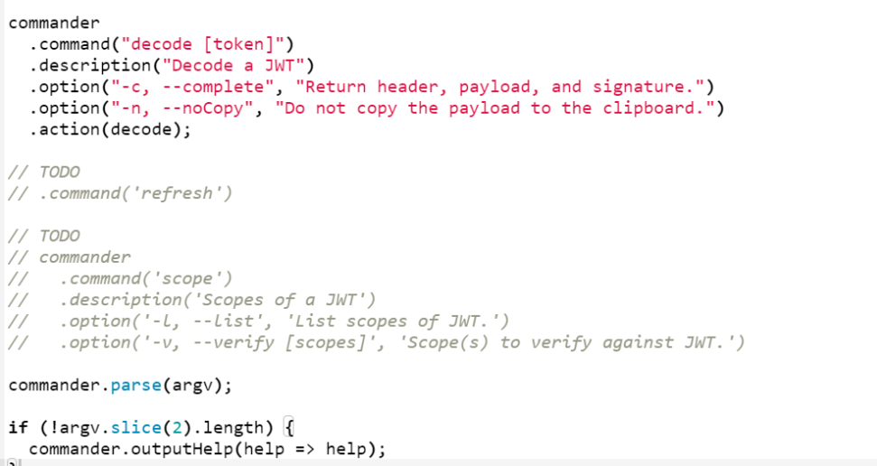

5.3 PROTOTYPE SUBMISSION
The steps in order the prt. was initiated and further tasks executed.
•Run the tool.
•In the login field the user submit the credentials.
•The server generates the verification token and return it to browser.
•Browser will send token with request to a restricted source.
•Server will identify the token whether the public & private key signatures are correct and the will respond to client
5.4 TEST AND VALIDATION

5.5 PERFORMANCE ANALYSIS
The tool gives a command line interface to a cyber security enthusiast or anyone related to the field. It provides a way for securely transmitting information between different parities in the form of JSON object .The sent or received information can be verified because they are digitally signed.
JWT is a great alternative to cookie-based authentication approach. It can have different usages: authentication mechanism, url-safe encoding, securely sharing private data, interoperability, data expiration, etc .JWTs can be used by a server to tell the client app what actions the user is allowed to execute

5.7 SUMMARY
JWT is a simple yet reliable mechanism to share security information between two parties. But, when you are using JWT, you need to be aware of the best practices to get the maximum from it.We had several cases where we wanted the users at HelpTap to logout by cleaning up the cookies, but we cannot ask them to do so every time. As well consider the case that a user’s mobile is stolen, and he wants to logout of all existing sessions(e.g. Gmail’s logout other sessions feature). Well its not possible in case of JWT. In our case it used to be rogue users. We needed to log them out. Well, in case of of HelpTap it was quite easy as we just had to delete the session tokens. There was no way to do the same in case of Bottr cause we used JWT in that case. You might argue, why not just delete the existing user-id from the table… But doing so means to create multiple dangling pointers and no one likes dangling pointers in a No-SQL database.

CHAPTER 6 PROJECT OUTCOME AND APPLICABILITY
6.1 OUTLINE
JWT is a great alternative to cookie-based authentication approach. It can have different usages: authentication mechanism, url-safe encoding, securely sharing private data, interoperability, data expiration, etc .JWTs can be used by a server to tell the client app what actions the user is allowed to execute
6.2 KEY IMPLEMENTATIONS OUTLINES OF THE SYSTEM
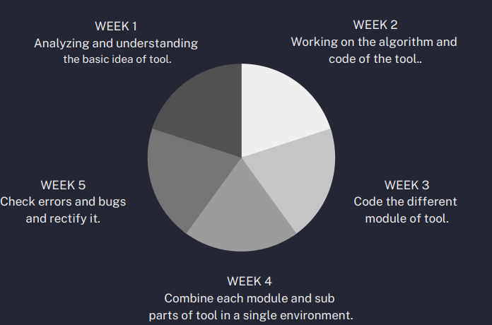

6.3 SIGNIFICANT PRT. OUTCOMES
Encryption Module
The desired information is encoded using a specified algorithm and secret phrase. Special information (defined in the Registered Claim Names section of standard) may be added, like expiration time. Some of this information, such as exp, is handled automatically by specific implementations. The output is a token of the following type aaaaa.bbbbb.ccccccc.
Decryption Module
The generated token is passed to a client. There are a few choices of where to store tokens in the client. For web application it can be a local storage or cookies. There is a discussion on the internet on this topic, such as. On requests, the token is attached to headers or passed in cookies, depending on chosen storage. The server app is responsible for decoding and validation of data encoded, as well as for resolving permissions.
6.4 PRT. APPLICABILITY ON REAL WORLD PROBLEMS

As we know 'Cryptography in everyday life' contains a range of situations where the use of cryptography facilitates the provision of a secure service: cash withdrawal from an ATM, Pay TV, email and file storage using Pretty Good Prvy. (PGP) freeware, secure web browsing, and use of a GSM mobile phone.
The confidential messages can be encrypted with ease and send directly to the receiver end where the message can be decrypted without any secy. breach and once done, it won’t leave any trace and gets completely erased. The major issue for the existing applications is the secy. breach which in case of this prt. there is no other channel working in between, its end to end secure process.
6.5 INFERENCE
JWT is a great alternative to cookie-based authentication approach. It can have different usages: authentication mechanism, url-safe encoding, securely sharing private data, interoperability, data expiration, etc .JWTs can be used by a server to tell the client app what actions the user is allowed to execute.
CHAPTER 7 CONCLUSION & RECOMMENDATION
7.1 OUTLINE
JWT is a simple yet reliable mechanism to share security information between two parties. But, when you are using JWT, you need to be aware of the best practices to get the maximum from it.We had several cases where we wanted the users at HelpTap to logout by cleaning up the cookies, but we cannot ask them to do so every time. As well consider the case that a user’s mobile is stolen, and he wants to logout of all existing sessions(e.g. Gmail’s logout other sessions feature). Well its not possible in case of JWT. In our case it used to be rogue users. We needed to log them out. Well, in case of of HelpTap it was quite easy as we just had to delete the session tokens. There was no way to do the same in case of Bottr cause we used JWT in that case. You might argue, why not just delete the existing user-id from the table… But doing so means to create multiple dangling pointers and no one likes dangling pointers in a No-SQL database.
7.2 LIMITATIONS/CONSTRAINTS OF THE SYSTEM
1. Compromised Secret Key
One of the major cons of relying on tokens is that it relies on just one key. Yes, JWT uses only one key, which if handled poorly by a developer/administrator, would lead to severe consequences that can compromise sensitive information.
It’s essential for businesses to seek professional help coupled with robust security mechanisms while planning to add JWT to their authentication mechanism to ensure the highest level of security.
2. Data Overhead
The overall size of a JWT is quite more than that of a normal session token, which makes it longer whenever more data is added to it.
So, if you’re adding more information in the token, it will impact the overall loading speed and thus hamper user experience. This situation can be fixed if right development practices are followed and minimum but essential data is added to the JWT.
3. Shorter Lifespan
Short-lived JWT are harder for users to work with. These tokens require frequent reauthorization, which can be annoying at times, especially for the clients.
Adding refresh tokens and storing them appropriately is the only way to fix this scenario where long-lived refresh tokens can help users stay authorized for a more extended period of time.

7.3 FUTURE ENHANCEMENTS
1. Token-based Authentication is more Scalable and Efficient
As we know that tokens are required to be stored on the user’s end, they offer a scalable solution. Moreover, the server just needs to create and verify the tokens along with the information, which means that maintaining more users on a website or application at once is possible without any hassle.
2. Flexibility and Performance
Flexibility and enhanced overall performance are other important aspects when it comes to token-based authentication as they can be used across multiple servers and they can offer authentication for diverse websites and applications at once. This helps in encouraging more collaboration opportunities between enterprises and platforms for a flawless experience.
3. Tokens Offer Robust Security
Since tokens like JWT are stateless, only a secret key can validate it when received at a server-side application, which was used to create it. Hence they’re considered the best and the most secure way of offering authentication.

7.4 INFERENCE
Enterprises can leverage tokens depending on the nature of the requirement and their individual business needs. Although JWT can be the right option in most scenarios if implemented correctly and securely by following the right security measures. However, one should consider the above-mentioned aspects before relying on a token for authentication and authorization.

REFERENCES
- Anderson, R., Biham, E., & Knudsen, L. (1998). Serpent: A proposal for the advanced encrt. standard. NIST AES Proposal, 174, 1-23.
- Abraham, O., & Shefiu, G. O. (2012). An improved Caesar ciph. (ICC) algorithm. International Journal Of Engineering Science & Advanced Technology (IJESAT), 2, 1198-1202.
- Saraswat, A., Khatri, C., Thakral, P., & Biswas, P. (2016). An extended hybridization of Vigenere and Caesar ciph. techniques for secure communication. Procedia Computer Science, 92, 355-360.
- Mishra, A. (2013). Enhancing secy. of caesar ciph. using different methods. International Journal of Research in Engineering and Technology, 2(09), 327-332.
- Gowda, S. N. (2016, September). Innovative enhancement of the Caesar ciph. algorithm for cryptography. In 2016 2nd International Conference on Advances in Computing, Communication, & Automation (ICACCA)(Fall) (pp. 1-4). IEEE.
- Hendi, A. Y., Dwairi, M. O., Al-Qadi, Z. A., & Soliman, M. S. (2019). A novel simple and highly secure method for data encrt.-decrt.. International Journal of Communication Networks and Information Secy., 11(1), 232-238.
- Agrawal, E., & Pal, P. R. (2017). A Secure and Fast Approach for Encrt. and Decrt. of Message Communication. Int. J. Eng. Sci, 11481.
- Goyal, K., & Kinger, S. (2013). Modified caesar ciph. for better secy. enhancement. International Journal of Computer Applications, 73(3), 0975-8887.
- Ephin, M., Joy, J. A., & Vasanthi, N. A. (2013). Survey of Chaos based Image encrt. and decrt. techniques. In Amrita International Conference of Women in Computing (AICWIC’13) Proceedings published by International Journal of Computer Applications (IJCA).
- Pakshwar, R., Trivedi, V. K., & Richhariya, V. (2013). A survey on different image encrt. and decrt. techniques. International journal of computer science and information technologies, 4(1), 113-116.
- Al-Hazaimeh, O. M. A. (2013). A new approach for complex encrypting and decrypting data. International Journal of Computer Networks & Communications, 5(2), 95.
- Limbong, T., & Silitonga, P. D. (2017). Testing the classic caesar ciph. cryptography using of matlab. Int. J. Eng. Res. Technol, 6(2), 175-178.

